Marks of Maturity:
Prayer and Fasting

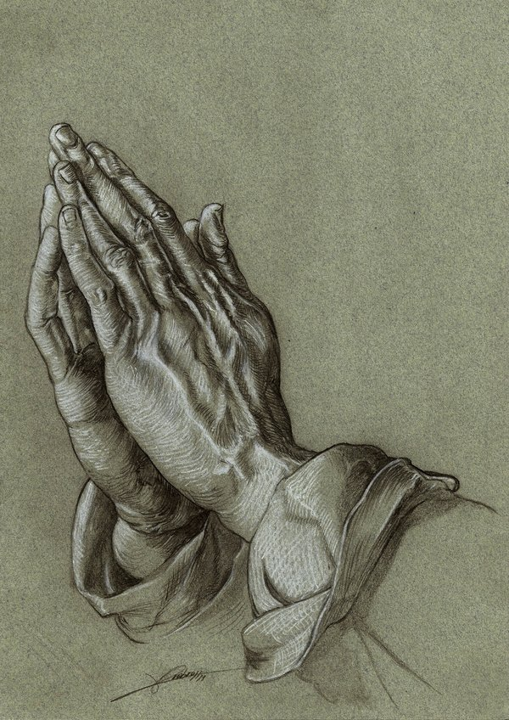

FCOC - August 2016

Jewish Prayer in the First Century

Prayer was a common part of life for religious Jews. They had free prayers (personal, original prayers), liturgical formula prayers (taught to the community to be repeated in times of worship), and special prayers taught by respected rabbis (see Luke 11:1). Some elements of “The Lord’s Prayer” have parallels in other rabbis’ special prayers, but at least two elements are uniquely Jesus’: “forgive us our trespasses/debts” and “lead us not into temptation/testing”.

The Temple had been called “a house of prayer” and synagogues (local gatherings for worship and instruction) were called “prayer houses” because of the importance of prayer in Jewish worship.

Prayer traditions developed within Judaism over the centuries, and it’s difficult to know for certain when many of them were in popular use. Jesus was likely raised to reciting the Shema (from Deut. 6:4) and at least part of what is known as the Eighteen Benedictions twice a day.

The Jews had – and still have – a morning prayer, an afternoon prayer, and an evening prayer (connected by rabbis to Abraham, Isaac, and Jacob, respectively).

Mature Prayer

Jesus taught us to pray in a way that honors Father alone. He taught us to pray in a simple trust that He knows our needs and understands what we tell Him. Our Master warned us against trying to manipulate our Father with babbling and repetitions as the pagans were prone to do. The mature prayer flows from a heart that is lovingly and reverently reliant on God, seeking His best interests and appealing to Him for one’s own.

The mature prayer is offered in humility and is accompanied by an admiration for Father which compels a person to become like Him. Thus, the mature prayer includes a commitment to forgive others even as it includes a petition for forgiveness from God. It is grand in vision and scope even while it is specific and detailed about personal needs.

The mature pray-er is too focused on the truly pressing and weighty matters of life in God’s kingdom to be concerned with how well he or she sounds to others or whether the prayer offered will garner admiration.

Simply put, the mature prayer is sincere, free of pretense, and entirely wrapped up in the goodness and glory of the One who hears it.

Jewish Fasting

The only fast required of the whole nation of Israel in the Law of Moses is that of the Day of Atonement (see Lev. 23:26-32). Other fasts that developed over time were held to commemorate important moments in the history of the nation: the capture of Jerusalem by Babylon, the burning of Jerusalem and the Temple by Babylon (and hundreds of years later by Rome on the same day of the year), the murder of Gedaliah (Jer. 41:1-2), and the siege of Jerusalem by Babylon. There were lesser fasts added to the Jewish tradition as well.

The Pharisees added fasting to their weekly routine as evidence of their piety and commitment to righteousness. Evidence suggests they commonly had two days per week set aside for fasting. Jesus seemed to have this more frequent personal fasting in view when He warned against fasting in the manner of the hypocrites.
Throughout the Old Testament narrative, fasting was practiced to show mourning and/or anguish as well as humble oneself before God in preparation for significant events (e.g. Esther’s preparation to approach the king).

Mature Fasting

Jesus called the Jews in His audience to fast for the honor of God alone. He warned them against using fasting as a means of garnering admiration from onlookers or of boasting about one’s righteousness. Fasting was meant to signify humility, but hypocrites were actually using it to be especially prideful. What a corruption!

Mature fasting is done in humble recognition that “man does not live on bread alone, but on every word that comes from the mouth of God” (Deut. 8:3 & Matthew 4:4). It is practiced for various reasons, but always to acknowledge dependence on Father and humility before Him. Mature fasting isn’t done in a way that calls attention to the one fasting.

Fasting can be done with others when serving God together (see Acts 13:1-3 and 14:23). It is never to be practiced as an isolated behavior; it is to accompany prayer, petitions, repentance, etc. It is a powerful tool in our life with God when practiced maturely; it is empty and aggravating to God when practiced hypocritically (see Isaiah 58).

